Scenario:

Create a Server-Side command, in Python

Command Name: sendmail

Command Parameters :

* To
* Subject
* From
* Body

First write a Unit Test ( pattern/best practice )

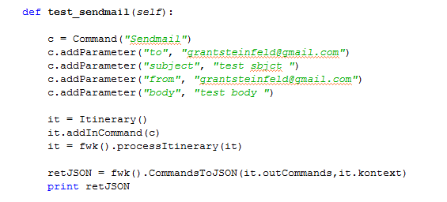

Then create the command in either

Core/src/src/framework/CoreCommands.py

or

Core/src/src/custom/DomainCommands.py

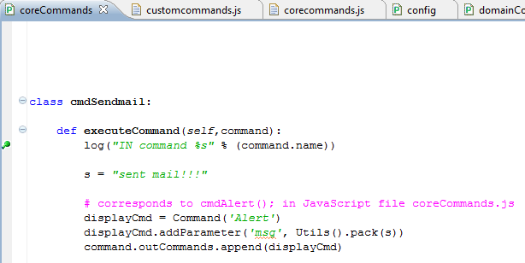

Do work

Reply command in this case is an Alert to the GUI indicating success “sent mail”

Alert is a known JavaScript GUI / local command and is in src/docs/framework/corecommands.js

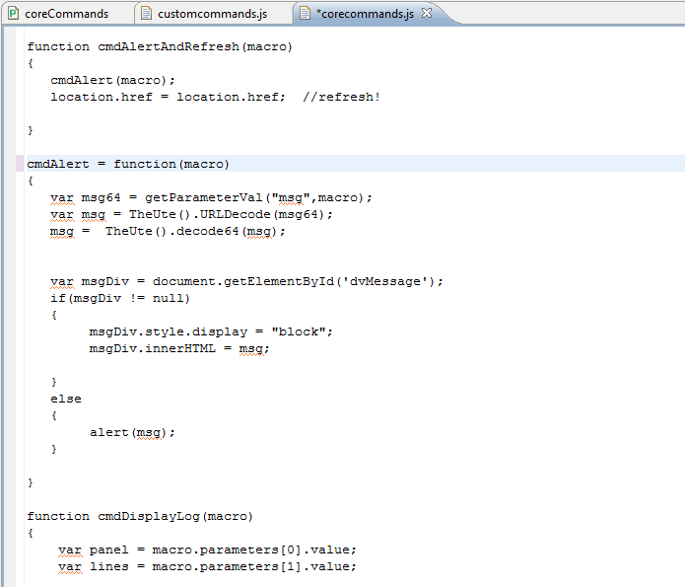

Wiring up Navigation, to a local command is done via the FWK.say(); which takes the form

Say(“JS command name”,”param1”,”param2” … )

This has a small down side in that the parameters are not named, but are positional

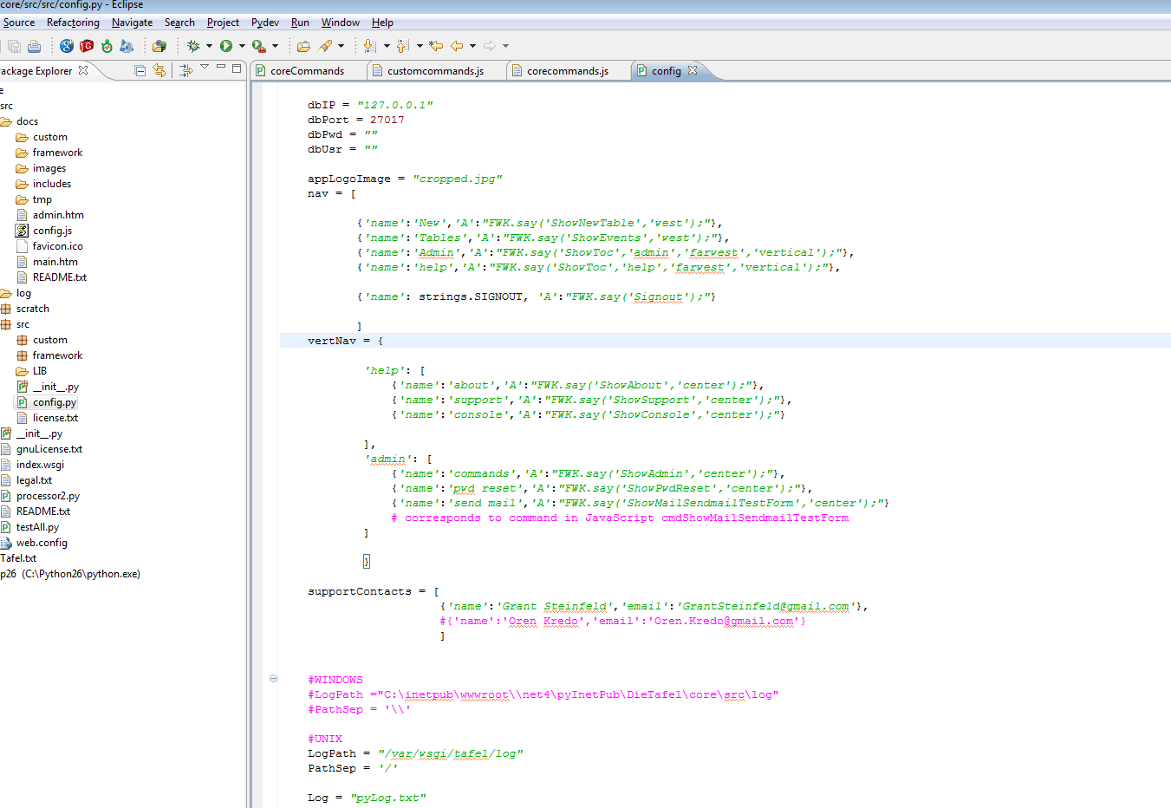

In this case we added a send mail vertical menu item in the admin group called cmdShowMailSendmailTestForm to be rendered to the ‘center’ panel << need item about GUI page layouts >>

In this case, we decided to put the command code in the custom javascript command file called customcommands.js

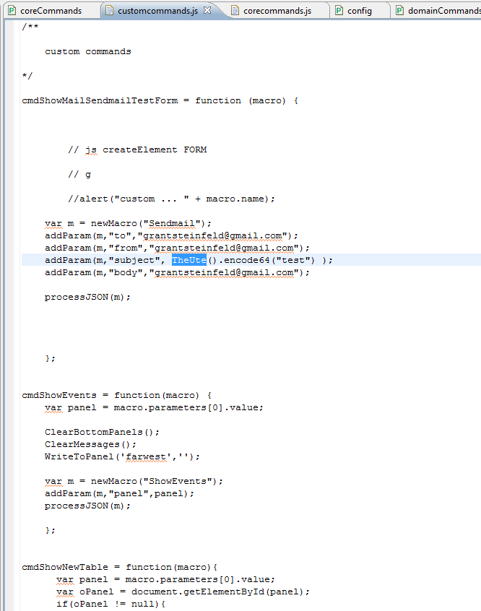

Config.py is the main config file

In this case the commandCoreTuple and commandDomainTuple are of interest. Here the namespace of the python command is set as well as an appropriate prefix.

<<names are important, ie needs prefix cmd for example>>

